1. 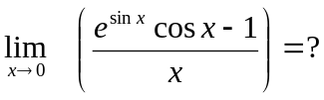

2. 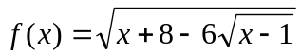
- Express f(x) in the simplest form.
- Graph f(x).
- 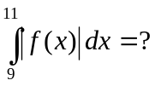

3. 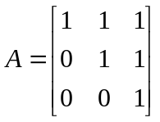 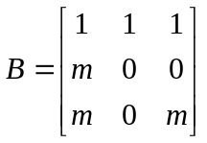

- For what m value(s) B is not invertible?
- If m is different than values in part (a) then B⁻¹=?
- Solve the equation BX=A (B is invertible.)

4. 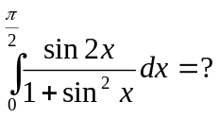

5. 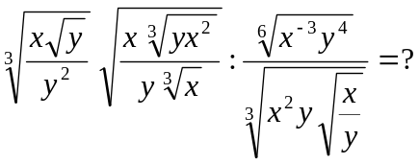

6. 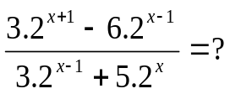

7. 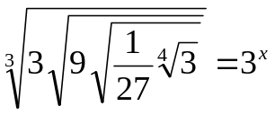 so x = ?

Comp No:

